REAL TIME WEATHER FORECASTING
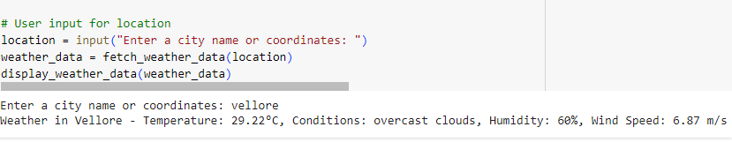
STOCK ANALYSING INVENTORY SYSTEM
